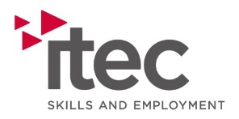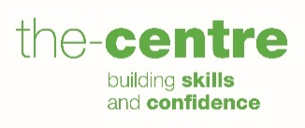

Job Description

Title: Compliance Officer

Summary/Purpose: To complete effective compliance auditing ensuring Itec maintains contractual compliance whilst enhancing our learner experience through frequent, impactful interventions both in person and digitally.

Reporting to: Head of Apprenticeships

Supervising: N/A

Responsibilities:
- Responsible for routine analysis of reports/key data to identify and action plan or potential compliance risks.
- Responsible for supporting the team to address identified compliance issues with assessors/customers.
- Responsible for tracking identified areas of concern to completion.
- Responsible for supporting the team to schedule tasks proactively.
- Accountable for reporting trend of non-compliance to the managers.
- Responsible for managing the risk rating of all assessor caseloads.
- Responsible for contributing to the review of internal compliance reports.

General
- To ensure security of company assets
- To comply with all company policies and procedures
- To comply with the companies safeguarding policy & procedure
- To comply with Equal Opportunities Legislation and be proactive in challenging prejudice, discrimination, and stereotyping.
- To implement in full the Company’s quality policies and procedures.
- To consult the Company Health and Safety Policy with regards to their specific responsibilities as described in the general arrangements section
- To give consideration to their actions at work as to how they may affect the safety of Learners, clients and visitors to Company premises.
- Support organisations core values
- Co-operate with all staff to achieve a healthy and safe workplace and reporting any risks identified, at the company’s or other premises, to the designated Health and Safety Officer.
- Other duties that may be identified from time to time by the Company.
- Attend relevant training / personal development programmes.

Person Specification

 | Essential | Desirable
Experience | - Working within customer service environment  - Working with quality (or similar) management systems  - Full driving licence with use of own vehicle | - Databases, e-portfolio systems, customer management systems  - Working withing education and learning sector  - Public funded support contracts  - Experience of carrying out internal audits
Qualifications & Training | - 5 GCSEs at Grade C or above or equivalent  - Literacy, Numeracy and Digital competency at least at Level 2 or equivalent | - Level 2 Management  - Internal Audit  - Degree or equivalent
Skills | - Excellent organisation skills  - Project planning and monitoring  - Target setting and monitoring  - Analytical  - Excellent attention to detail  - Logical and systematic thinking  - Critical thinking and problem-solving skills  - Working knowledge of MS Office applications – Word, Excel, Outlook, Teams | - Ability to speak Welsh  - Internal auditing skills
Knowledge | - Business processes and management systems  - Business standard (s) | - Knowledge of the WBL Specification and Quality Agenda  - Safeguarding Knowledge and understanding  - Professional / business standards
Characteristics | - Open-minded, result-oriented with positive “can-do” attitude  - Confident  - Personable  - Active Listener  - Influencing through evidence  - Willingness to share advice and knowledge  - Values opinions of others  - Adaptability  - Self-motivated

NAME __________________________________

SIGNATURE _____________________ DATE _____________________

